Project Design Phase-II
Technology Stack (Architecture & Stack)

Date | 10 July 2026
Team ID
Project Name | CAB BOOKING
Maximum Marks | 4 Marks

Technical Architecture:
he Cab Booking System follows a MERN Stack architecture, where the React.js frontend communicates with the Node.js and Express.js backend through REST APIs. The backend manages user authentication, ride booking, driver assignment, fare calculation, and payment processing, while MongoDB Atlas securely stores user, driver, ride, and payment data. External services such as Google Maps API are integrated for location tracking and route navigation. The technical architecture diagram and the information in Table 1 and Table 2 illustrate the application's components, technologies, infrastructure, and data flow.
Example: Online Cab Booking and Ride Management System
Reference: https://developer.ibm.com/patterns/ai-powered-backend-system-for-order-processing-during-pandemics/
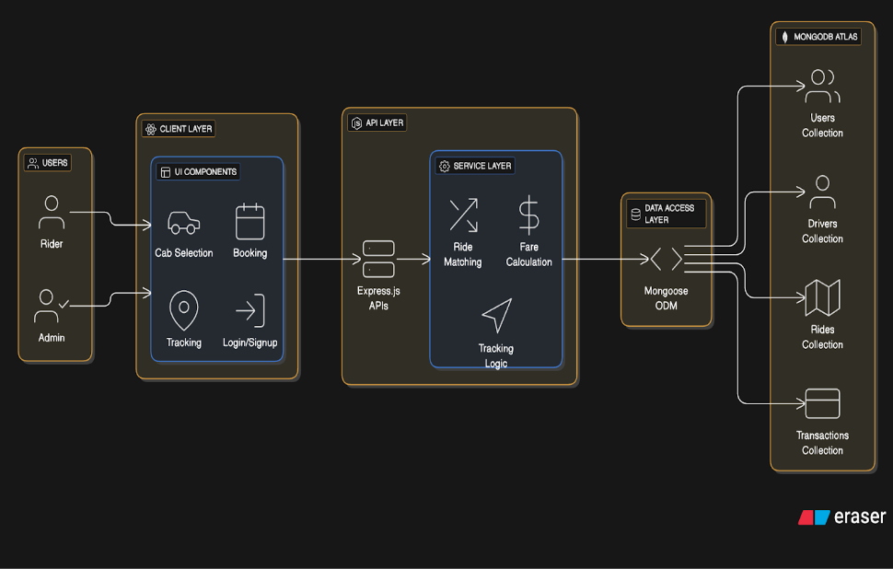
Guidelines:
- Include the complete application workflow, infrastructure (Local/Cloud), external APIs (Google Maps, Payment Gateway), and MongoDB database components in the solution architecture.
- Clearly illustrate the interaction between the frontend, backend, database, and third-party services; machine learning is not applicable in the current version.

Table-1 : Components & Technologies:
S.No | Component | Description | Technology
- 1 | User Interface | Web application for Riders, Drivers, and Admin | HTML5, CSS3, JavaScript, React.js
- 2 | Application Logic-1 | User Authentication & Authorization | Node.js, Express.js, JWT, crypt
- 3 | Application Logic-2 | Ride Booking & Driver Management | Node.js, Express.js
- 4 | Application Logic-3 | Fare Calculation & Ride Tracking | JavaScript, Express.js
- 5 | Database | Stores Users, Drivers, Rides & Payments | MongoDB
- 6 | Cloud Database | Cloud-hosted database service | MongoDB Atlas
- 7 | File Storage | Profile images and documents (optional) | Local Storage / Cloud nary
- 8 | External API-1 | Maps, Location & Directions | Google Maps API
- 9 | External API-2 | Payment Gateway | Razor pay / Stripe
- 10 | Machine Learning Model | Not Applicable | N/A
- 11 | Infrastructure (Server/Cloud) | Backend API Hosting | Node.js Server, Render / Railway / Localhost

Table-2: Application Characteristics:
S.No | Characteristics | Description | Technology
- 1 | Open-Source Frameworks | Frameworks used for application development | React.js, Node.js, Express.js, MongoDB
- 2 | Security Implementations | Secure Login, Password Encryption & JWT Authentication | crypt, JWT, HTTPS
- 3 | Scalable Architecture | MERN Stack supports future growth and multiple users | React.js, Express.js, MongoDB
- 4 | Availability | Application available 24×7 through cloud deployment | MongoDB Atlas, Render
- 5 | Performance | Fast API response and optimized database queries | Express.js, MongoDB Indexing

References:
https://c4model.com/
https://developer.ibm.com/patterns/online-order-processing-system-during-pandemic/
https://www.ibm.com/cloud/architecture
https://aws.amazon.com/architecture
https://medium.com/the-internal-startup/how-to-draw-useful-technical-architecture-diagrams-2d20c9fda90d

